**Chat GPT vs. Deep-Seek: A Comparative Analysis**

Artificial Intelligence (AI) has revolutionized the way we interact with technology, and conversational AI models like Chat GPT and Deep-Seek are at the forefront of this transformation. Both platforms are designed to facilitate human-like interactions, but they differ in their underlying technologies, use cases, and capabilities. In this article, we’ll explore the key differences between Chat GPT and Deep-Seek, helping you understand which tool might be better suited for your needs.

**What is Chat GPT?**

Chat GPT, developed by OpenAI, is a state-of-the-art language model based on the Generative Pre-trained Transformer (GPT) architecture. It is designed to generate human-like text responses based on the input it receives. Chat GPT has gained widespread popularity for its ability to engage in meaningful conversations, answer questions, and even assist with creative tasks like writing essays, coding, and brainstorming ideas.

**Key Features of Chat GPT:**

1. **Natural Language Processing (NLP):** Chat GPT excels in understanding and generating text that mimics human conversation.
2. **Versatility:** It can be used for a wide range of applications, including customer support, content creation, and education.
3. **Ease of Use:** The interface is user-friendly, making it accessible to both technical and non-technical users.
4. **Continuous Learning:** OpenAI frequently updates the model to improve its accuracy and performance.



**What is Deep-Seek?**

Deep-Seek, on the other hand, is a specialized AI platform that focuses on deep learning and data analysis. While it may not be as well-known as Chat GPT, Deep-Seek is designed to handle complex tasks such as data mining, pattern recognition, and predictive analytics. It is particularly useful for businesses and researchers who need to process large datasets and extract actionable insights.

**Key Features of Deep-Seek:**

1. **Data-Driven Insights:** Deep-Seek is optimized for analyzing structured and unstructured data to identify trends and patterns.
2. **Advanced Algorithms:** It uses sophisticated machine learning algorithms to deliver accurate predictions and recommendations.
3. **Customization:** Deep-Seek can be tailored to specific industries, such as finance, healthcare, and retail.
4. **Scalability:** It is capable of handling massive datasets, making it ideal for enterprise-level applications.

**Chat GPT vs. Deep-Seek: Key Differences**

| **Aspect** | **Chat GPT** | **Deep-Seek** |
| --- | --- | --- |
| **Primary Function** | Conversational AI and text generation | Data analysis and predictive modeling |
| **Target Audience** | General users, content creators | Businesses, researchers, analysts |
| **Strengths** | Natural language understanding | Data mining and pattern recognition |
| **Use Cases** | Customer support, content creation | Financial forecasting, healthcare analytics |
| **Ease of Use** | User-friendly interface | Requires technical expertise |
| **Scalability** | Suitable for small to medium tasks | Designed for large-scale datasets |

**Use Cases: Where Each Shines**

**Chat GPT:**

1. **Customer Support:** Chat GPT can be integrated into chatbots to provide instant responses to customer queries.
2. **Content Creation:** Writers and marketers use Chat GPT to generate blog posts, social media content, and ad copy.
3. **Education:** Students and educators leverage Chat GPT for tutoring, essay writing, and research assistance.
4. **Entertainment:** It can create stories, jokes, and even engage in casual conversations.

**Deep-Seek:**

1. **Financial Forecasting:** Deep-Seek analyzes market trends to predict stock prices and investment opportunities.
2. **Healthcare Analytics:** It helps researchers identify disease patterns and develop treatment plans.
3. **Retail Optimization:** Deep-Seek analyzes customer behavior to improve inventory management and marketing strategies.
4. **Fraud Detection:** It identifies unusual patterns in financial transactions to prevent fraud.

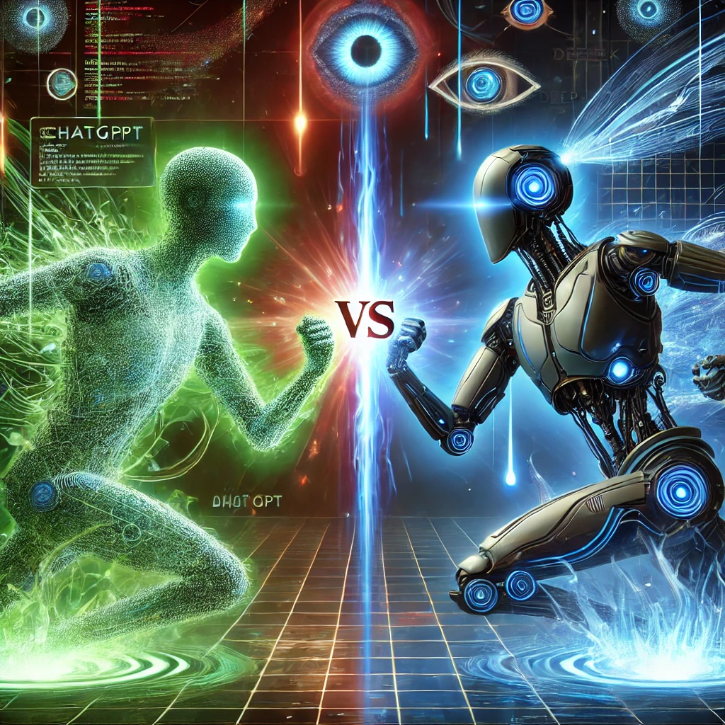

**Advantages and Limitations**

**Chat GPT:**

* **Advantages:**
  + Highly versatile and easy to use.
  + Capable of generating creative and engaging content.
  + Continuously updated with new features and improvements.
* **Limitations:**
  + May produce inaccurate or biased responses.
  + Limited ability to handle complex data analysis tasks.

**Deep-Seek:**

* **Advantages:**
  + Exceptional at processing and analyzing large datasets.
  + Provides actionable insights for decision-making.
  + Highly customizable for industry-specific needs.
* **Limitations:**
  + Requires technical expertise to operate effectively.
  + Less suited for general conversational tasks.

**Which One Should You Choose?**

The choice between Chat GPT and Deep-Seek depends on your specific needs:

* If you’re looking for a tool to assist with content creation, customer support, or casual interactions, **Chat GPT** is the better option.
* On the other hand, if your focus is on data analysis, predictive modeling, or industry-specific applications, **Deep-Seek** is the way to go.

**Visual Comparison**

*Caption: A visual representation of the key differences between Chat GPT and Deep-Seek.*

**Conclusion**

Both Chat GPT and Deep-Seek are powerful AI tools, but they serve different purposes. Chat GPT is ideal for text-based tasks and general interactions, while Deep-Seek excels in data-driven applications. By understanding their strengths and limitations, you can choose the right tool to meet your needs and unlock the full potential of AI.